42nd Textile Research Symposium Extended Abstract Format

Sueo Kawabata* and Masako Niwa**
* Kyoto University, Kyoto, Japan, **Nara Women’s University, Nara, Japan

1. Introduction
The 42nd Textile Research Symposium will be held on this coming August 28 (Wed) – 30 (Fri), 2013 in the Fuji Institute of Education and Training (Kyouiku Kenshusho) at the foot of Mt. Fuji. This annual symposium has started in 1972 as a domestic meeting for the purpose of promoting textile research and communication between scientist and/or technologists. Today it has become an inter-national conference on textile research covering a wide range of fields from fiber science to apparel engineering.

The format of extended abstract is as follows: Use A4 papers, within 1 page, 11 point, Times New Roman, leave margins of 2.5 cm at the top, the bottom, the right, and at the left. Title: Times New Roman, 14 pt, bold, center aligned. Authors: Times New Roman, 12 pt, center aligned. Affiliation: Italic, Times New Roman, 12 pt, center-aligned. The text content should be written in double- column format with a column width of 82 mm and a column spacing of 6 mm.

2. Experimental
2.1 Samples
These are samples used in this experiment.
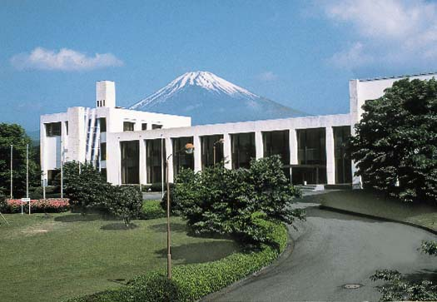
Fig. 1 Fuji Institute of Education Center
(Fuji Kyouiku Kenshusho) at the
foot of Mt. Fuji.

3. Results and Discussion

Table 1 Tentative Conference Schedule
Date | Program
Aug. 28 (Wed) | 13:00 Opening,  Oral Presentation
Aug. 29  (Thurs) | 8:30-17:00  Oral Presentations &  Poster session
Aug. 30  (Fri) | 8:30-12:00  Oral Presentations  13:00-17:00 Optional Tour

4. Conclusions

Important date:

Extended Abstract: by July 15, 2013.

Application of final registration: by July 29, 2013.

Full paper: August 28, 2013 to the front desk of the symposium by printed manuscripts.

References
1. S.Kawabata, M.Niwa, H.Kawai, J. Text. Inst.,
64, 1-61 (1973).
2. S.Kawabata, M.Niwa, M.Matsudaira, J. Text.
Mach. Soc., 31, 17-14 (1985).

