42nd Textile Research Symposium Full Paper Format

Sueo Kawabata* and Masako Niwa**
* Kyoto University, Kyoto City, 615-8510, Japan,
**Nara Women’s University, Nara City, 630-8506, Japan

Abstract
Systematic research works were carried out to clarify the effects of weave density, yarn twist and yarn count on fabric handle of polyester fabrics made for the purpose and following results were ob-tained. “KOSHI” and “HARI” increase with weft yarn density and “SHINAYAKASA” and “SHARI” decrease with the density. The effect of the density on “FUKURAMI” and “KISHIMI” are small.

1. Introduction
The 42nd Textile Research Symposium will be held on this coming September 28 (Wed) – 30 (Fri), 2013 in the Fuji Institute of Education and Training (Kyouiku Kenshusho) at the foot of Mt. Fuji. This annual symposium has started in 1972 as a domestic meeting for the purpose of promoting textile research and communication between scientist and/or technologists. Today it has become an inter-national conference on textile research covering a wide range of fields from fiber science to apparel engineering.
The full paper (within 6 pages for oral presentation and within 3 pages for a poster presentation) should be handed at the front desk of the symposium on August 28. The manuscript should be made as camera-ready manuscripts and be handed over at the conference registration desk or sent to the organizer in advance by airmail. This is an example of 1st and last pages of the full paper.

The format of full paper is as follows: Use A4 papers, 11 point by Times New Roman, leave margins of 2.5 cm at the top, the bottom, the right, and at the left. Title: Times New Roman, 14 pt, bold, center aligned. Authors: Times New Roman, 12 pt, center aligned. Affiliation: Italic, Times New Roman, 12 pt, center aligned. Abstract: Times New Roman, 11 pt, both-side justified. The text content should be written in double - column format with a column width of 82 mm and a column spacing of 6 mm.

2. Experimental
2.1 Samples
These are samples used in this experiment.

3. Results and discussion

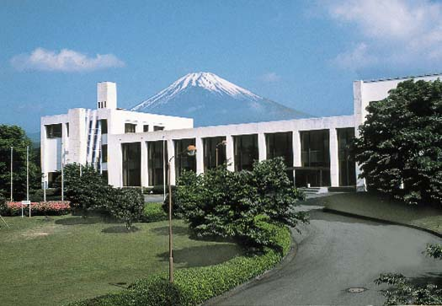
Fig. 1 Fuji Institute of Education Center

Table 1. Tentative Conference Schedule
Date | Program
Aug.28 (Wed) | 13:00 Opening,  Oral Presentation
Aug. 29  (Thurs) | 8:30-17:00  Oral & Poster Presentations
Aug. 30  (Fri) | 8:30-12:00  Oral Presentations  13:00-17:00 Optional Tour

4. Conclusions

Important date:

Extended Abstract: by July 15, 2013.

Application of final registration: by July 29, 2013.

Full paper: August 28, 2013 to the front desk of the symposium by printed manuscripts.

References
1. S.Kawabata, M.Niwa, H.Kawai, J. Text.
Inst., 64, 1-61 (1973).
2. S.Kawabata, M.Niwa, M.Matsudaira, J. Text.
Mach. Soc., 31, 17-14 (1985).

