46th Textile Research Symposium Extended Abstract Format

Sueo Kawabata* and Masako Niwa**
* Kyoto University, Kyoto, Japan, **Nara Women’s University, Nara, Japan

1. Introduction
The 46th Textile Research Symposium will be held on this coming September 3(Mon) -5(Wed), 2018 in Teijin Academy Fuji. This annual symposium has started in 1972 as a domestic meeting for the purpose of promoting textile research and communication between scientist and/or technologists. Today it has become an international conference on textile research covering a wide range of fields from fiber science to apparel engineering.

The format of extended abstract is as follows: Use A4 papers, within 1 page, 11 point, Times New Roman, leave margins of 2.5 cm at the top, the bottom, the right, and at the left. Title: Times New Roman, 14 pt, bold, center aligned. Authors: Times New Roman, 12 pt, center aligned. Affiliation: Italic, Times New Roman, 12 pt, center-aligned. The text content should be written in double-column format with a column width of 82 mm and a column spacing of 6 mm.
The extended abstract for both oral and poster presentation should be prepared in PDF file.
The abstract will be printed in color.

2. Experimental
2.1 Samples
These are samples used in this experiment.
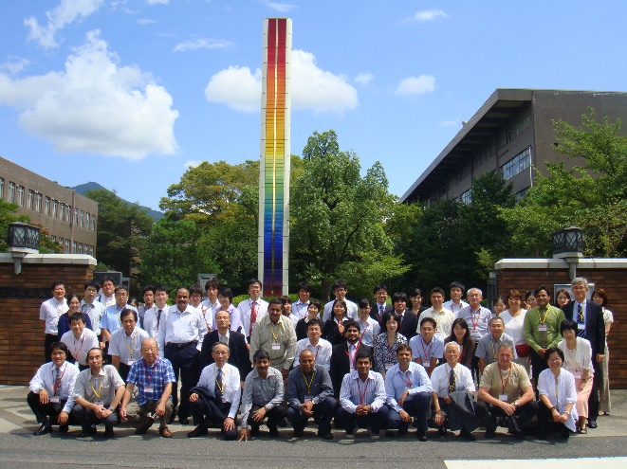
Fig.1 40th Textile Research Symposium

3. Results and Discussion

Table 1 Tentative Conference Schedule
Date | Program
Sep. 3  (Mon) | Opening  Oral Presentation
Sep. 4  (Tue) | Oral Presentation  Poster session
Sep. 5  (Wed) | Oral Presentation  Optional Tour

4. Conclusions

Important date:

Extended Abstract: by July 20, 2018

to the Textile Machinery Society of Japan:

E-mail: info@tmsj.or.jp

Application of final registration: by July 31, 2018 to the Textile Machinery Society of Japan:

https://tmsj-orjp.sslwww.jp/entry.php

date of issue：Aug 27, 2018

References
1. S.Kawabata, M.Niwa, H.Kawai, J. Text. Inst.,
64, 1-61 (1973).
2.S.Kawabata, M.Niwa, M.Matsudaira, J. Text.
Mach. Soc., 31, 17-14 (1985).

